Lab assignments

1-Design the following layout using grid system

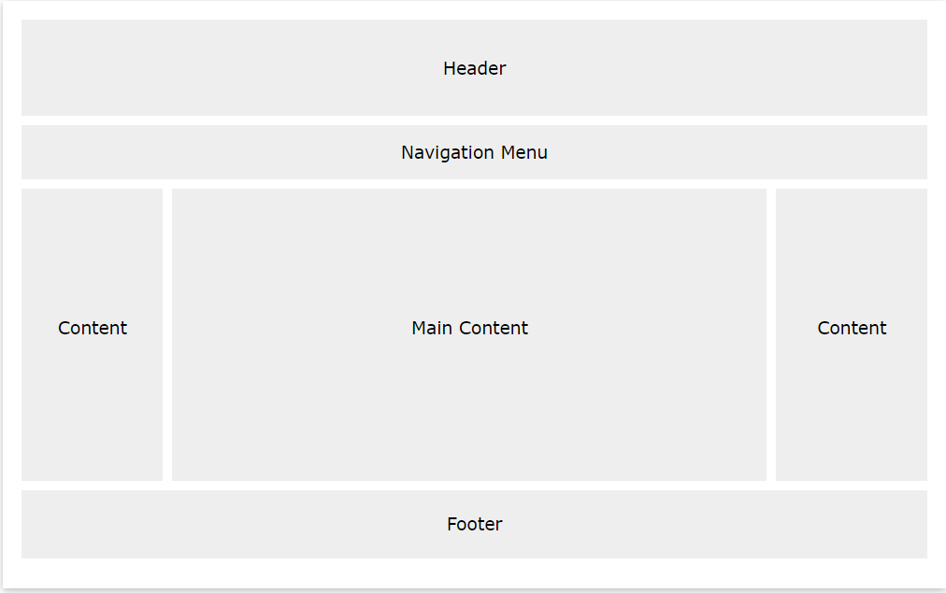

2-Start with [this webpage](https://www.teaching-materials.org/_deprecated/csstools/exercises/exercise_media_before), which already has HTML and CSS for a header, navigation, content, sidebar, and footer. This is what it looks like

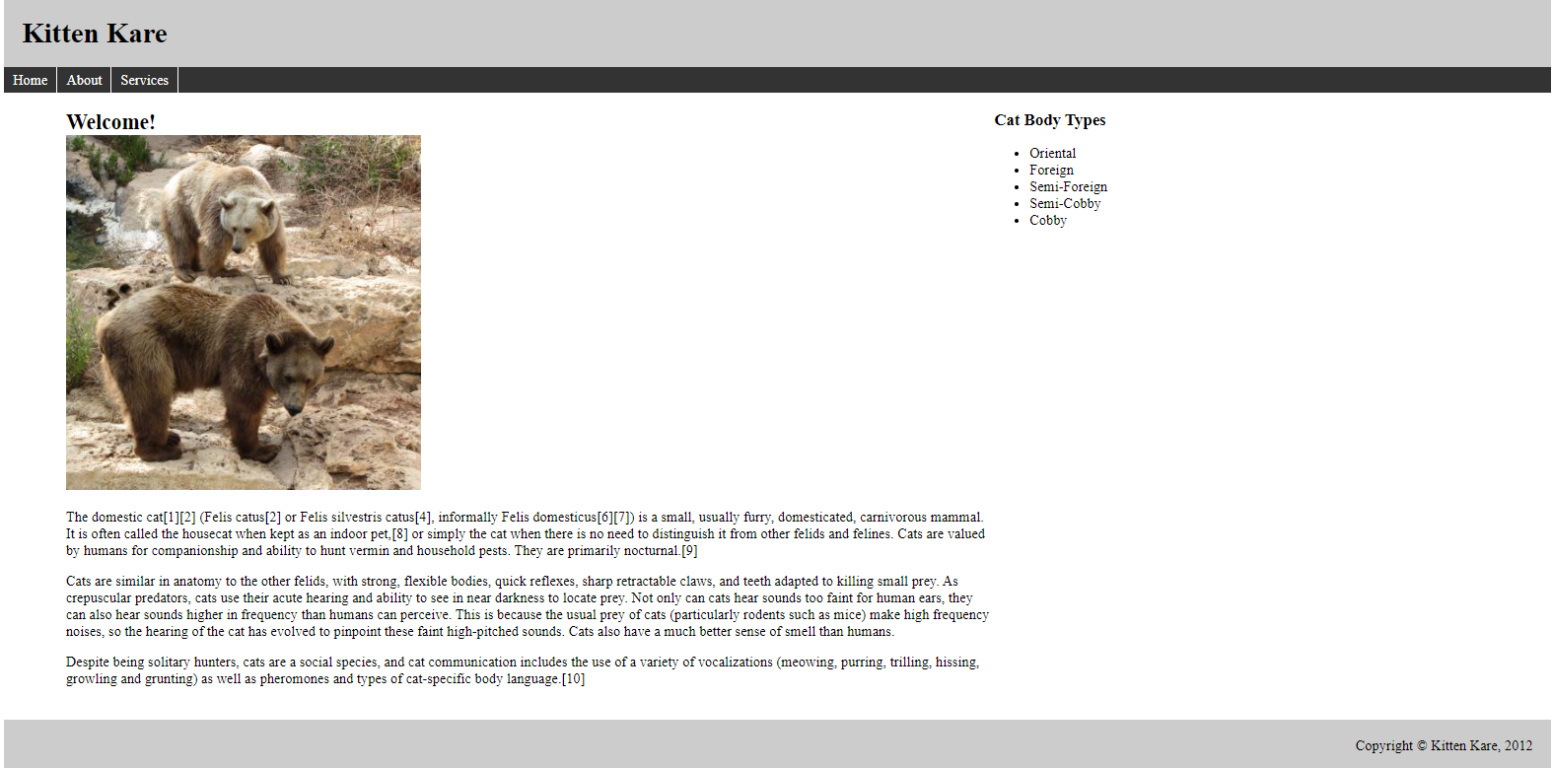

Add a CSS media query and appropriate styles so that the webpage looks like the screenshot below when printed. Specifically:

* The header, navigation, and footer should be hidden.
* The sidebar should display under the main content.

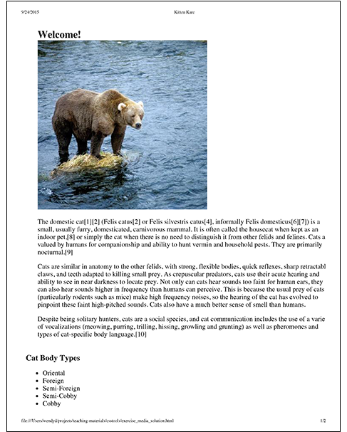

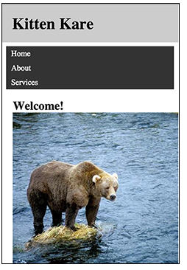

Add a CSS media query and appropriate styles so that the webpage looks like the screenshots below when resized to smaller widths. Specifically:

* The sidebar should be hidden.
* The body should have no padding.
* The images shouldn't exceed the width of the window.
* The navigation items should each be on their own line.
* The header should be fixed, so that it stays at the top after scrolling.

3-Redo the last lab assignment number 1,2 using grid system.

4- make a demo to change all page style in any width. (Two files CSS)